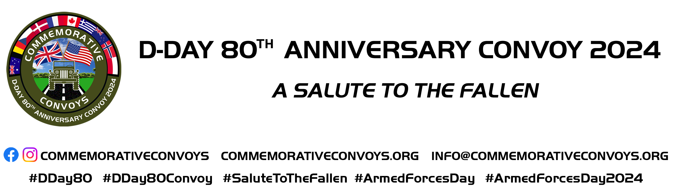

INFORMATION and REGISTRATION
Thank you for your interest in participating in the D-Day 80th Anniversary Convoy – A Salute to The Fallen which will take place on Saturday 29 June 2024. The Convoy will form part of a full weekend of events 29 and 30 June being hosted in Hungerford, West Berkshire. The weekend of events is being planned in conjunction with Hungerford Town Council and The Town and Manor of Hungerford. With support from West Berkshire Council, Newbury BID and various Authorities and communities in North Hampshire, and West Berkshire.
This will be a unique commemorative event and as far as we are aware, there are no other events of this scale being planned elsewhere.
Join the convoy and / or have a static display on the show site.
We hope you find the important information helpful. If you have any questions, please get in touch info@commemorativeconvoys.org. We are happy to help.

For the latest news, please follow us and “like” our Facebook / Instagram and check our website:

commemorativeconvoys Web: https://www.commemorativeconvoys.org
Armed Forces Day Logo © Crown Copyright / The Ministry of Defence Commemorative Convoys Logo © Lee Sainsbury
Following the success of a short-run military vehicle convoy supporting the 2017 production of Greenham 100 Years of War and Peace hosted at the former RAF / USAAF airfield in Berkshire, interest was generated in organising a stand-alone convoy event.
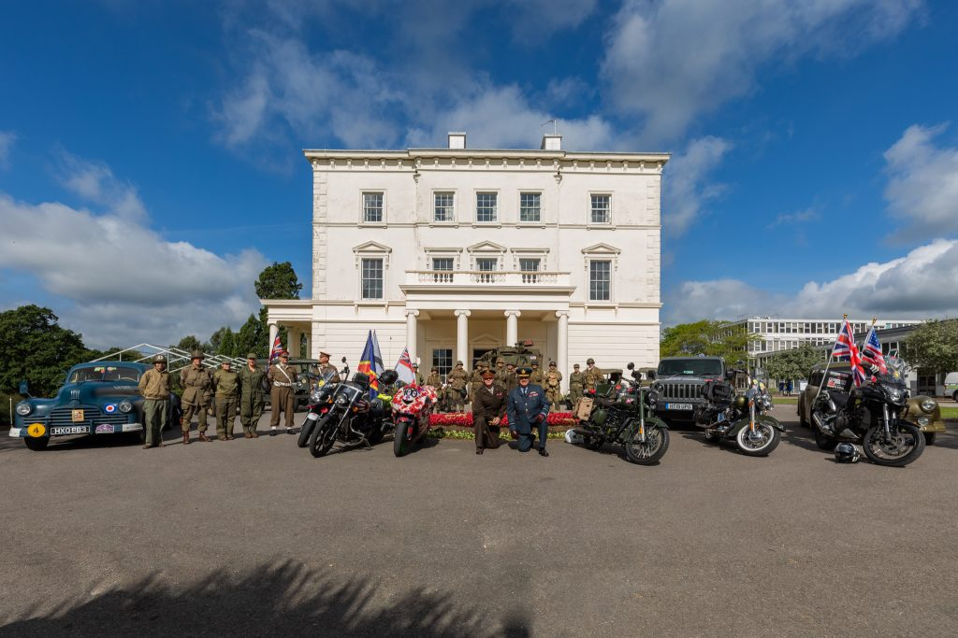
Two of the organisers involved with the 2017 event recognised the 75th Anniversary of D-Day in 2019 as the perfect opportunity. Planning commenced in June 2018.
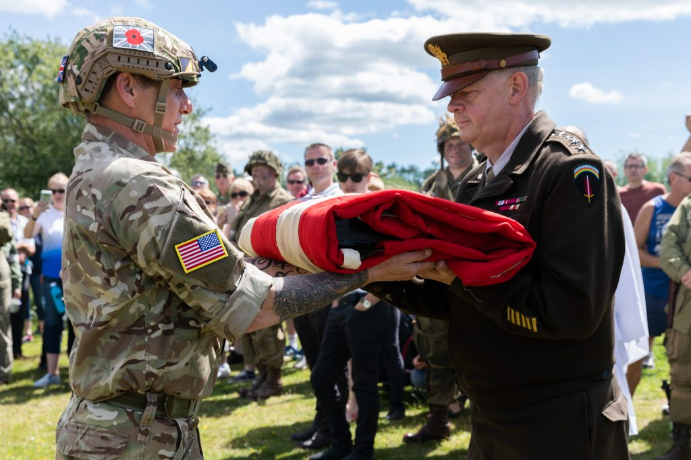
Based on a re-enactment of the historic 50-mile journey made by General Eisenhower, on the afternoon of 5 June 1944, the potential convoy route was identified as Southwick House, near Fareham (former D-DAY HQ) to former RAF/USAAF Greenham Common.
On 25 June 2019, a convoy of over sixty classic military vehicles and over 30 motorcycle escort riders’ courtesy of the Royal British Legion Riders Branch was flagged off from Southwick House by WREN veteran Marion Loveland, a former member of the D-Day Communications Team at HMS Collingwood.
On arrival at Greenham Common, an act of Remembrance was conducted for all those who flew from the base during Operation Overlord and in memory of those who never returned.
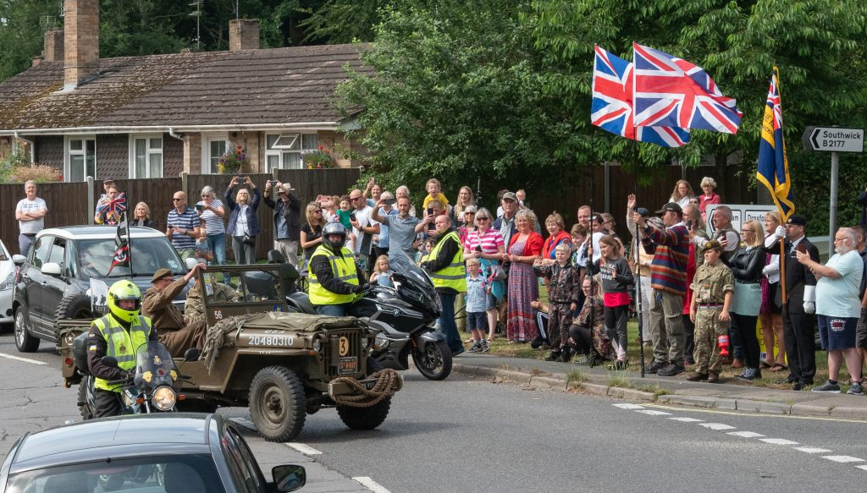
It was not possible to organise events in 2020 and 2021 however, efforts were nonetheless being made to resume the convoy as soon as the opportunity occurred. With renewed enthusiasm the event returned in June 2022 on Armed Forces Day as a Salute to the Veterans, coinciding with the 40th Anniversary of the Falklands War, but including veterans of other conflicts.
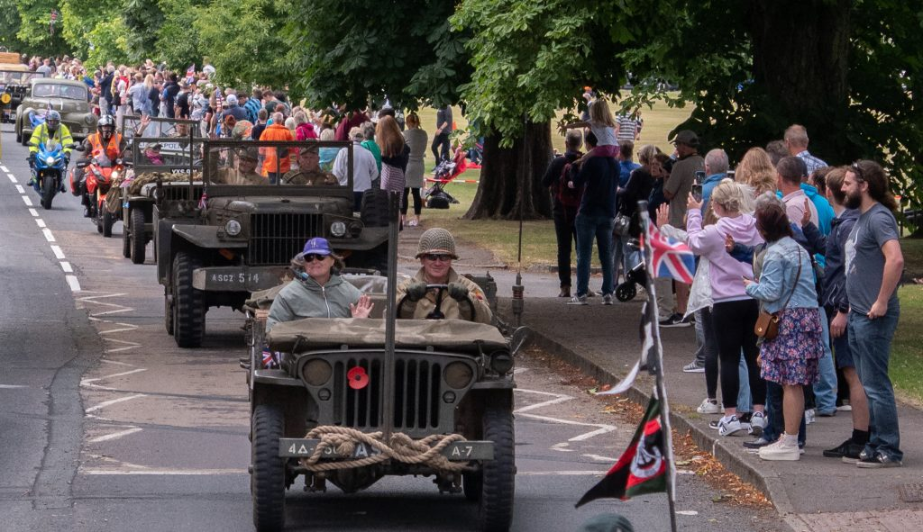
A shorter route of thirty-seven miles, Southwick House to Milestones Living History Museum Basingstoke, attracted nearly 70 vehicles with the support of the Royal British Legion Riders Branch. We were also very pleased to welcome Royal Navy Riders.
On Armed Forces Day in June 2023, we presented anther convoy event in association with Alton Town Council Hampshire
To date, our convoys have successfully raised money for charity and have gained positive feedback from our sponsors and the public.
The volunteer organising team members are:
Lee Sainsbury
Graeme Cunningham
Chris Lambden
Ann Burchett
Kate Keppel
Maxine Knott
Stephen Gough
John Leete
Michael Burne on behalf of the Military Vehicle Trust

Current Event Details: D-Day 80th Anniversary Convoy – A Salute to The Fallen
The Route: The route is Basingstoke to Hungerford via Kingsclere, Main Street, Greenham Business Park, and Newbury Town Centre
Start Point: Milestones Living History Museum, Basingstoke, Hampshire, RG22 6PG
What3Words: ///modern.zones.total

End Point: Triangle Field show site, Priory Rd, Hungerford, RG17 0AP
What3Words: ///reefs.snap.dined

Distance: Approx. 30 Miles
Convoy Start Time: 10:00*
Convoy Arrival Time: 12:15*
*Subject to traffic conditions

Show Field Public Opening Hours (To Be Confirmed):
Saturday 29 June 2024: 10:00 – 16.30
Sunday 30 June 2024: 10:00 – 16:00

Also, with activities throughout the town on both days including evening entertainment Saturday.

Participation Terms and Conditions
Registration: We ask all vehicle owners to complete the registration form with as much detail as possible. This information is required for both Risk Assessment and Health and Safety. Information you supply will be kept confidential but may be shared with our co-organisers if they need some specific date in the running of the event.
Event Information Updates: Please note that for this 2024 event, we will keep you updated with regular social media and emails.
Joining The Convoy: Access to the Basingstoke site from 7 am. We ask all vehicles/owners to be at the start point by no later than 9:00 am on the 29th June 2024. This gives time for registration, refreshments, use of comfort facilities, photographs, and general Convoy administration.
Leaving The Event: As this is a significant event, we would ask all participants not to leave the Hungerford event field early unless by prior arrangement. Departure times If you are attending on Saturday (only) will be 4:00 pm and on Sunday 3:00 pm.
Lunch Bags: We hope to be able to provide a complimentary lunch bag, during the stopover at Greenham. Unfortunately, we cannot cater specifically for vegetarians, vegans, or any allergens. If you need something specific, please bring your own refreshments.
Flags: Commemorative Convoys are non-political and non-aligned. We ask that Flags of the Allied Nations only be flown from vehicles during this event.
Green (Period Camping): Triangle Field, Priory Rd, Hungerford, RG17 0AP
What3Words: ///reefs.snap.dined

Red (Modern Camping): The Croft Field Centre, The Croft, Hungerford, RG17 0HY
What3Words: ///moving.scouts.unleashed
Camping: We can provide complimentary space for this event with comfort facilities and showers. Pre-booking essential. Access from Friday 28th June, but please ask if you need to arrive earlier. Please contact us as soon as possible to reserve your space.
Please advise if you prefer to join the convoy at Main Street, Greenham Business Park RG19 6AW. The convoy stops here between 11 am and 11:30 am. Please be on-site by no later than 10.30 am. Please advise if you wish to static display only at the Hungerford show site.
Any details you supply will be used by Commemorative Convoys and we may share your details with Hungerford Town Council and The Town and Manor of Hungerford, the joint organisers of the weekend event.
Any details given will not be shared with any other third-party organisation without your permission.
Your details will be securely stored in an encrypted format.

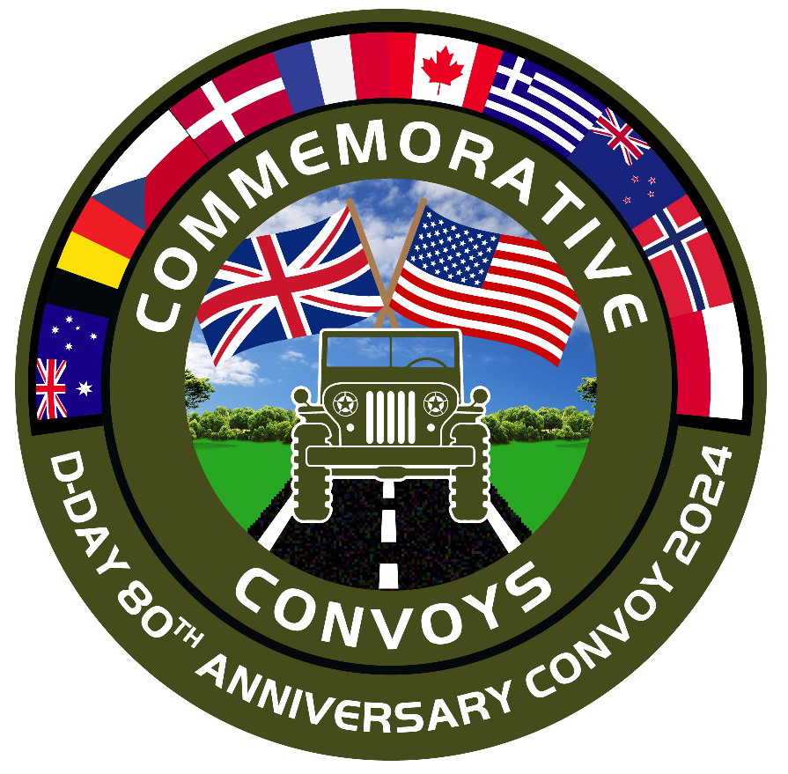
D-DAY 80th ANNIVERSARY CONVOY 2024
A SALUTE TO THE FALLEN
29TH JUNE 2024

VEHICLE REGISTRATION FORM
Completing this form
This form is a PDF. Save it to your computer and open it in Adobe Reader. If you don’t have Adobe Reader, it can be downloaded from here: https://get.adobe.com/uk/reader
From the “Sign” menu, click “Sign” and then “Fill & Sign”. Click on the first highlighted box and you will be able to type your details. Click each highlighted box and complete the details. Once completed, save the PDF, and send it to: vehicles@commemorativeconvoys.org. You can also print and post the form to Michael Burne at 61 New Road Chilworth, Guildford, Surrey GU4 8LP
Please include details of your Vehicle Insurance at the foot of this form. Sign and date. Thanks
If you cannot complete this form electronically, simply send the details in an email to the above email address or post.

Name:
Address:

Email:
Landline: Mobile:
Telephone:

Vehicle (s) Make /
Model: (S)

Vehicle Reg: (s)

The deadline for vehicle registrations and camping bookings is Sunday 5th May 2024.

